ORDER FORM

ART MATERIALS AND PRICING
Please fill out the sections in green font
Note:
- Price is per subject (bust)
  - Full body: added cost $20
  - Background: added cost will vary
- 50% Nonrefundable deposit

- Traditional drawing portraits - $80
1a. Pencil
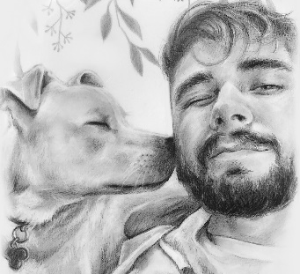
1b. Charcoal
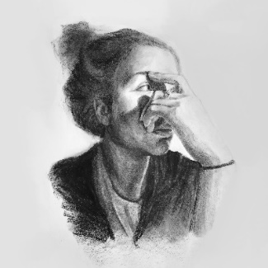

- Digital Portraits - $60
(File or Physical Print)
2a. Monochrome
2b. Color

- Acrylic Portrait (Pets Only) - $120

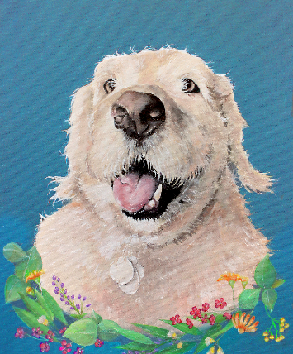

CONTACT INFORMATION
First & Last Name | Click or tap here to enter text.
Email | johnsmith@email.com
Art Materials Used | Choose an item. (Please see above for materials and pricing information)
Framed and Shipped? | ☐Yes ☐No (If yes, mailing information will be discussed through email)
Dimensions of Artwork | Ex. “9x12” (Photo on next page for size references)
Time Frame for Completion | Ex. “Three weeks” or maybe “No specified time frame”

Extra Comments, Questions, Notes:
Please provide comments or notes here.

SIZE REFERENCE (DIMENSIONS IN INCHES)
